|  |
| --- |
| NEW **OBJECTIVES** (Polar Coordinates, Section 6.4, Pages 479 – 485) |
| * Identify the major parts of the polar coordinate system: the Pole, Polar Axis, and Polar points in the form (r, *θ*). |
| * Understand that the Polar point (*r, θ*) has the coordinate *r,* which is the distance from the Pole and the coordinate *θ,* whichis an angular measure, either in degrees or radians. |
| * Understand that *(x, y)* is a Rectangular (Cartesian) point. |
| * Plot points in the Polar coordinate system. |
| * Be able to convert from (*r, θ*) to *(x, y)* by using x = rcos *θ* and y = rsin *θ.* |
| * Be able to convert from *(x, y)* to *(r, θ)* by using r = ±√ (x2 + y2) and *θ* = tan-1(y/x). |
| * Graph and identify the Common Polar Curves. |
| * Use a TI84+ calculator to graph polar functions. |
| **The Polar Coordinate System** consists of a ray known as the Polar Axis and the endpoint of the ray, called the Pole. |

**TUESDAY (2.25.25)**

* **JS will present the following previously assigned work.**

**Refer to Example 3 on page 480 to do the following work:**

**Convert the points A, B, and C to their corresponding rectangular (Cartesian) coordinates.**

From circular trig, remember that cos *θ =* x/rand sin *θ =* y/r.

As a result, you will use x **= rcos *θ* and y = rsin *θ.***

**A: (r, θ) = (___,____); (x, y) = ( ___,____)**

**B: (r, θ) = (___,____); (x, y) = ( ___,____)**

**C: (r, θ) = (___,____); (x, y) = ( ___,____)**

* **Finish your Quiz (*Solving Trig Equations*), which was given on 2.20.25.**
* **Class Work/Homework:** Page 484 (#1 – 6).

**THURSDAY (2.27.25)**

* **Discuss the previously assigned homework/classwork:** Page 484 (#1 – 6).

Now plot the points in #1 – 4 on the Polar/Cartesian plane below:

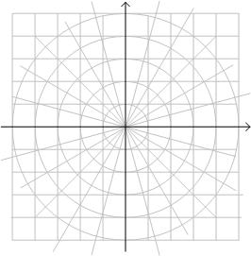

* **Plot the points that have these polar coordinates and give their corresponding rectangular coordinates:**

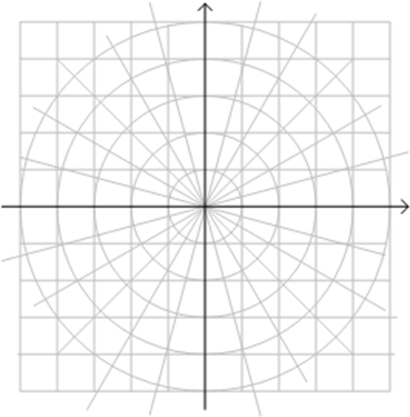**D** (2.5, 0o) _____________

**E** (3, - 135o) ____________

**F** (1, 30o) ____________

**G** (-1, 30o) ____________

**H** (1, -30o) ____________

**J** (-1. -30o) ____________

**K** (-2, π/4) ____________

**L** (1, 5π/4) ____________

**M** (-3, - 2π/3) ____________

**Study for a Quiz (*Converting Polar to Rectangular Coordinates and Plotting* *their Points on the Polar Cartesian Plane*) to be taken on Friday**. You may use your notes, written on 2 sheets of paper, 8.5 by 11 inches, front and back. You may Not use your calculator.

**FRIDAY (2.28.25)**

* **Quiz (*Converting Polar to Rectangular Coordinates and Plotting* *their Points on the Polar Cartesian Plane*) to be taken on Friday**. You may use your notes, written on 2 sheets of paper, 8.5 by 11 inches, front and back. You may Not use your calculator.
* **Class Work/Homework:** Study Example 4 on page 481, *Converting from* ***Rectangular to Polar Coordinates* by using r = ±√ (x2 + y2) and *θ* = tan-1(y/x).** Then, do #27 - 30 **(Part (a) only)** on page 484.  **Also,** #31 – 34.